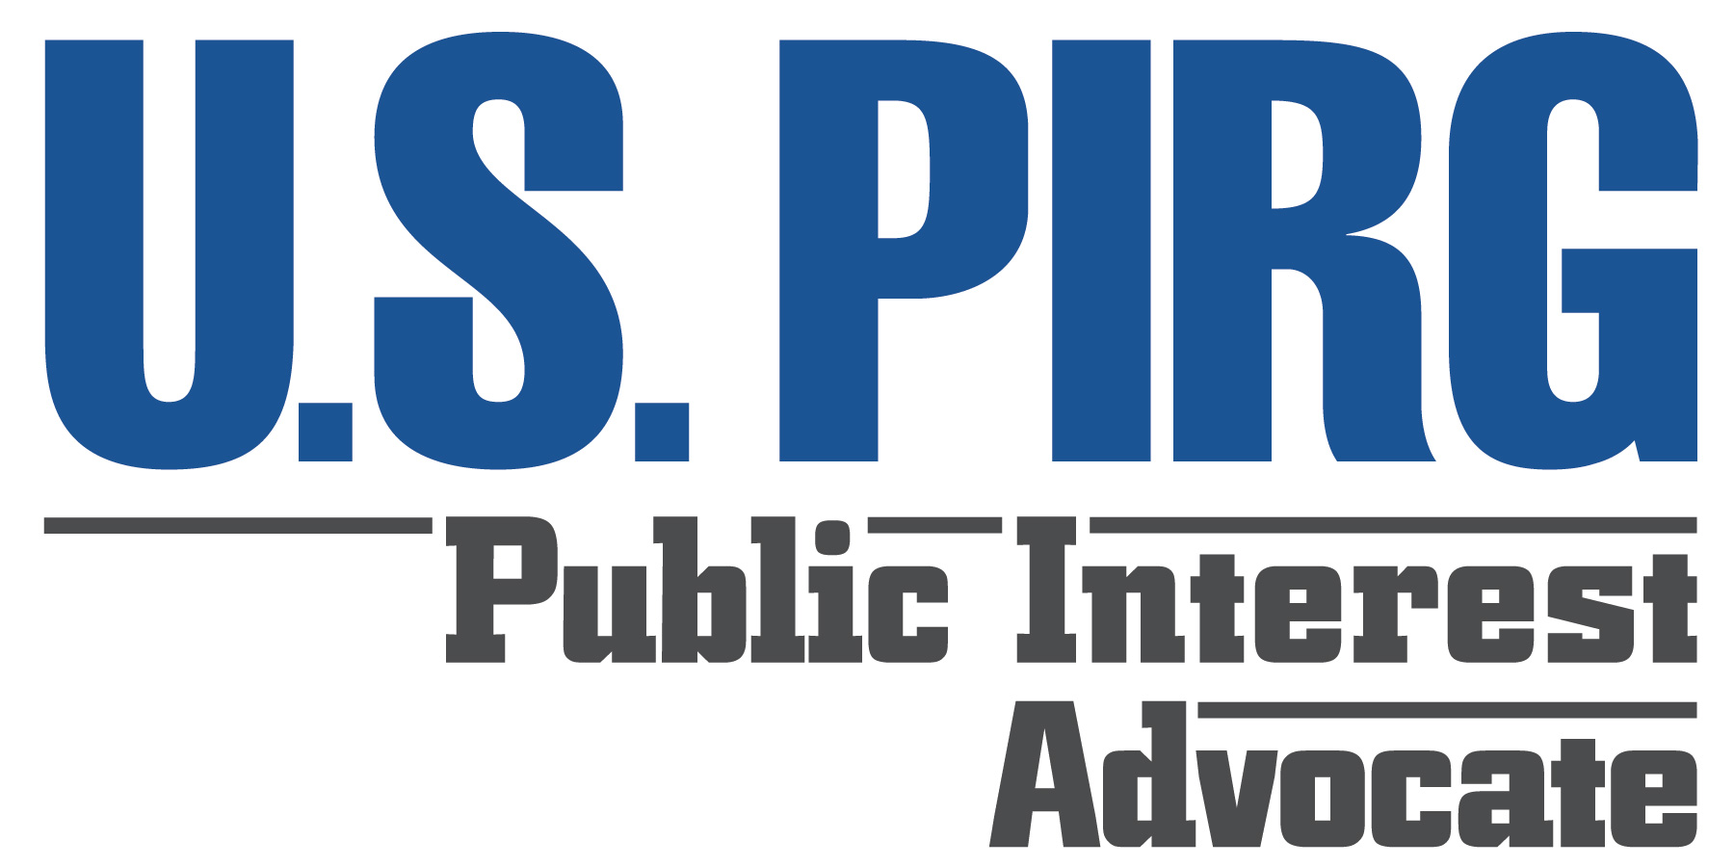

Global Warming Legislation in the 110th Congress
January 2007

This fact sheet provides an overview of the global warming bills introduced so far in the 110th Congress. The graph below, prepared by the World Resources Institute, compares the bills with pathways for stabilizing the concentration of global warming pollutants in the atmosphere at 450 parts per million (ppm) and 550 ppm; the chart provides a more detailed overview of the legislation.

Many scientists and policymakers (such as the European Union) recognize a 2˚ Celsius (3.6˚ Fahrenheit) increase in global average temperatures over pre-industrial levels as a rough limit beyond which large-scale, dangerous impacts of global warming would become unavoidable. To have a reasonable chance of keeping global temperatures from rising by more than 2˚C, the atmospheric concentration of carbon dioxide must be held below 450 ppm. The Sanders-Boxer and Waxman bills are the only ones that provide for stabilizing emissions near 450 ppm.

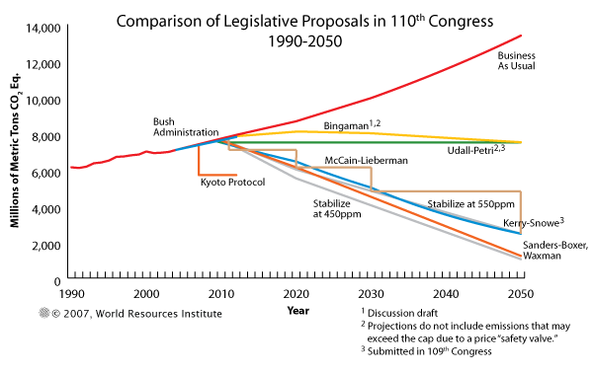
Summary of Global Warming Legislation (as of Jan. 20, 2007)

 | Safe Climate Act | Global Warming Pollution Reduction Act  (S. 309)
Lead sponsor(s) | Waxman | Sanders and Boxer
Scope of bill | Covers all U.S. global warming emissions. | Covers all U.S. global warming emissions.
Emission reduction targets | 2010: Emissions frozen at 2009 levels.  2020: 1990 levels (achieved by reducing emissions by approximately 2% per year from 2011-2020).  2050: 80% below 1990 levels (achieved by reducing emissions by about 5% per year from 2021-2050).  Note: 2020 target is equivalent to a 15% reduction from current (2005) levels; 2050 target is equivalent to an 83% reduction from current levels. | 2020: Reduces emissions to 1990 emission levels (achieved by reducing emissions by approximately 2% per year from 2010-2020).  2050: 80% below 1990s levels. (Also includes 2030 and 2040 interim targets.)  Note: 2020 target is equivalent to a 15% reduction from current (2005) levels; 2050 target is equivalent to an 83% reduction from current levels.
Major programs established to achieve emission reduction targets | (1) Cap-and-trade program for large emitters;  (2) Global warming emission standards for cars and light-trucks;  (3) National renewable energy standard; and  (4) National energy efficiency standard.  In addition, provides EPA additional regulatory authority to reduce emissions to the levels required under the bill. | Allows EPA to develop cap-and-trade program and requires the following programs:  (1) Global warming emission standards for cars and light-, medium-, and heavy-duty trucks;  (2) Global warming emission standards for power plants;  (3) Low carbon generation requirement for power plants;  (4) Energy efficiency performance standard;  (5) Renewable energy standard;  (6) Renewable fuels standard; and  (7) Consideration of climate change in environmental impact statements.
Scientific review | National Academy of Sciences, every five years. | National Academy of Sciences, every three years.

 | Climate Stewardship and Innovation Act (S. 280) | Draft Bingaman Bill | Electric Utility Cap-and-Trade Act  (S. 317)
Lead sponsor(s) | Lieberman and McCain | Bingaman | Feinstein and Carper
Scope of bill | Covers emissions from companies that (1) own or control an electric power, industrial, or commercial sector facility that emits more than 10,000 metric tons of greenhouse gases per year; or (2) refine or import petroleum products for use in transportation that, when combusted, will release more than 10,000 metric tons of greenhouse gases per year. | Covers all U.S. global warming emissions. | Covers carbon dioxide emissions from power plants.
Emission reduction targets | 2012: Emissions reduced to 2004 levels.  2020: 1990 levels.  2030: 22% below 1990 levels.  2050: 60% below 1990 levels.  Also, allows offsets (up to 30% of a company's emission reduction obligation in a given year) that would erode actual emission reductions from large emitters and borrowing (up to 25% of a company's emission reduction obligation in a given year) that would delay actual emission reductions.  Note: 2020, 2030, and 2050 targets are equivalent to a 15%, 33%, and 66% reduction from 2004 levels, respectively. | Does not set hard cap on emissions, but instead establishes emission "intensity" (emissions per unit of GDP) targets.  According to EIA, the targets would allow total U.S. global warming emissions to increase by 14% by 2020 and by 22% by 2030 relative to 2004 levels.  Also, the bill allows unlimited offsets that would erode the actual emission reductions.  In addition, companies can buy emission allowances directly from the government at a set price, starting at $7 per metric ton of carbon dioxide equivalent, further eroding the reductions. | 2011-2014: Emissions reduced to 2006 levels.  2015: 2001 levels.  2016-2019: 1% below preceding year’s emissions.  2020 and after: 1.5% below preceding year’s emissions.  Also, the bill allows offsets that would erode actual reductions from power plants.  Note: 2020 target is equivalent to an 11% reduction from current (2005) levels.
Major programs established to achieve emission reduction targets | Cap-and-trade program. | Tradable permits program. | Cap-and-trade program.
Scientific review | Under Secretary of Commerce for Oceans and Atmosphere, every two years. | None. | Establishes Climate Science Advisory Panel, requires review at least every four years.

John Larsen, World Resources Institute, Global Warming Legislation in the 110th Congress, 18 January 2007. Note that the data on the Bingaman bill extrapolate the target to 2050.
Malte Meinshausen, “What Does a 2˚C Target Mean for Greenhouse Gas Concentrations? A Brief Analysis Based on Multi-Gas Emission Pathways and Several Climate Sensitivity Uncertainty Estimates,” in Hans Joachim Schnellnhuber, ed., Avoiding Dangerous Climate Change, Cambridge University Press, 2006.
Malte Meinshausen, “What Does a 2˚C Target Mean for Greenhouse Gas Concentrations? A Brief Analysis Based on Multi-Gas Emission Pathways and Several Climate Sensitivity Uncertainty Estimates,” in Hans Joachim Schnellnhuber, ed., Avoiding Dangerous Climate Change, Cambridge University Press, 2006. Meinshausen estimated that carbon dioxide stabilization at 450 ppm would result in a mean probability of 54 percent that global average temperatures would increase by more than 2˚C versus pre-industrial levels. By contrast, stabilizing carbon dioxide concentrations at 400 ppm would reduce the mean probability of exceeding a 2˚C increase to 28 percent.
The bill has not yet been re-introduced, but no substantive changes are planned.
Allows for an acceleration of the emission reductions to prevent (1) the average global temperature from increasing by more than 3.6˚ Fahrenheit (2˚Celsius) over the pre-industrial average; or (2) global atmospheric concentrations of global warming pollutants from exceeding 450 ppm.
September 2006 draft bill.
Energy Information Administration, Energy Market and Economic Impacts of a Proposal to Reduce Greenhouse Gas Intensity with a Cap and Trade System, January 2007.
Allows 2020 and later targets to be revised based on science review and EPA rulemaking.

